WEEKEND MACEDONIAN DANCES IN GRONINGEN
29 and 30 maart 2008
by Saško Anastasov from Veles (Macedonia)

In October 2006 Saško taught us with a lot of enthousiasm some authentic Macedonian dances, accompanied by his tapan, a clarinetplayer and an accordeonplayer. This year he will come again, also with live music!

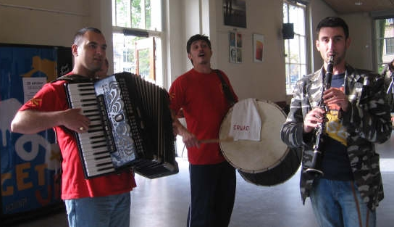

Times: saturday 29 March 12.30 - 17.30 h
sunday 30 March 10.30 – 15.30 h
Location: Praedinus gymnasium, Turfsingel 82, Groningen (with place for cars)
Costs: Whole weekend: € 35,- (+ voluntary amount for the music)
just saturday: € 22,-

Please pay cash when you arrive
For the people who want we will have dinner on saturdaynight in the Macedonian restaurant.

Register and information: Marja Roorda
tel: 050 5267275
email: marjaroorda@hotmail.com

Last date to register: 20 maart 2008
(There will be a maximum of 40 people)

(This weekend is not suitable for people who just started to dance)

