There will be a course video, add your name to the list on the day  Enclose SAE if you require a receipt  Local Guest Houses  The following are a selection close to the school taken from Yellow Pages  Swan Guest house  17 Nyewood Lane, Bognor Regis 01243 826880  Selwood Lodge  93 Victoria Drive, Bognor Regis 01243 865071  Homestead Guest House  90 Aldwick Road, Bognor Regis 01243 823443  GeoVerdi Guest House,  Victoria Drive, Bognor Regis. 01243 828390 | Weekend of Greek  Folk Dances  with  Angie Saravelaki  17th & 18th February 2007  Bognor Regis  Cost £36 both days. £20 one day  Times:  Saturday 10:15 (for 10:30) to 5:00  Sunday 10:00 to 4:30  There will be a one hour lunch break each day.  Please bring packed lunch.  for information etc: Janet Douglas  92 Rose Green Road  Bognor Regis  West Sussex  PO21 3EQ  Tel: 01243 265010  email: Angie@interfolk.co.uk
Main Hall  Bognor Regis Community College  Main School,  Westloats Lane  On the A259 in Bognor follow brown signs for the Arena and white signs for Bognor Regis Community College. Westloats Lane is a turning south of theA259 near a pedestrian crossing (with traffic lights). In Westloats Lane go straight across at crossroad, the school is the big red building on the right.  Anyone coming on foot from the station: follow Linden Road to traffic lights, go straight on (now Collyer Avenue) until Westloats Lane, turn left.  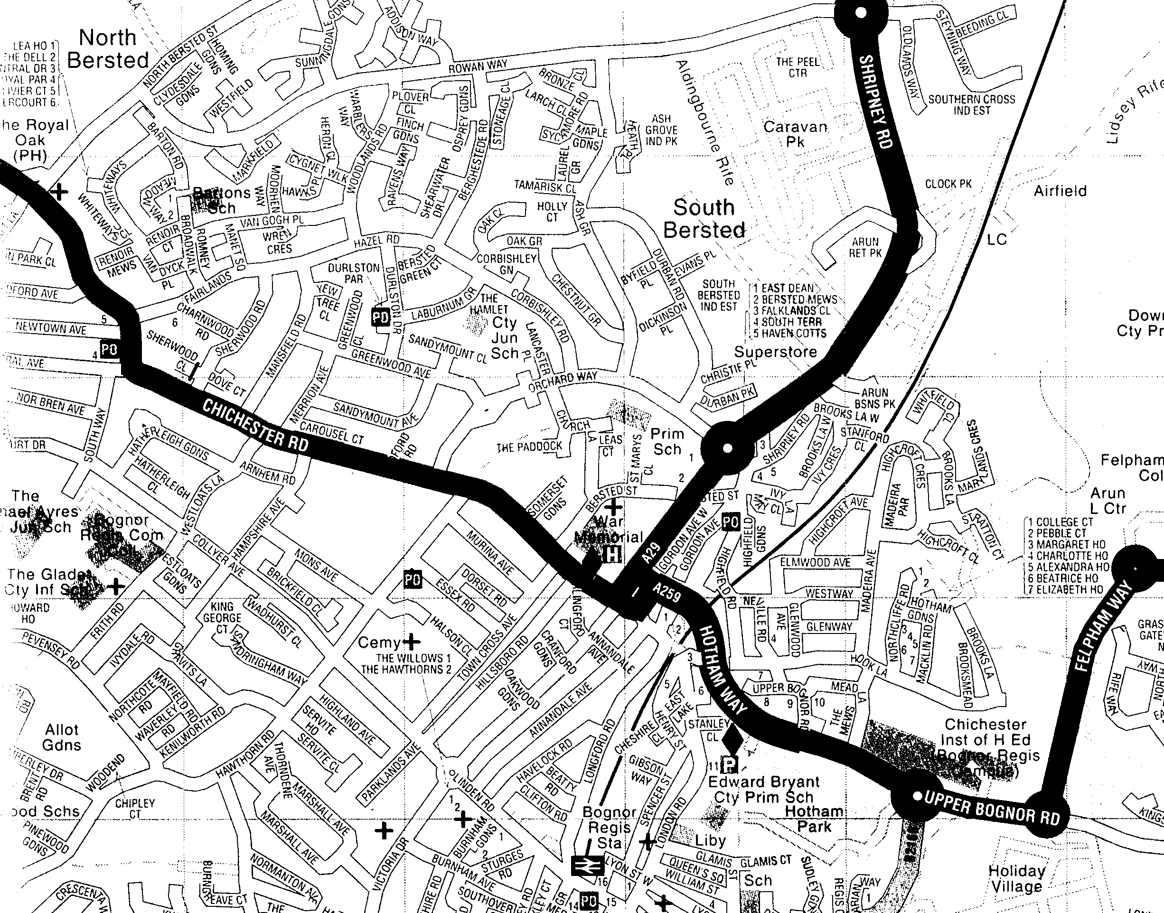 | Weekend Booking Form  To book, with a deposit of £10 per person, sending the remainder by 1st Januuary . (Please relieve us of the task of collecting money on the day)  Name(s) : ....................................................  Address : ....................................................  ....................................................  ....................................................  ....................................................  Telephone : ....................................................  email : ...........................................................................  Saturday Evening  for those spending the night in Bognor Regis:  We expect to meet up in a local restaurant in the evening.  This flyer is download from Balkanfolk Calendar  www.balkanfolk.com

