Balkanfolk Ltd.,
8 Karlovo Str., Sofia 1233 , Bulgaria
tel.: +359 2 832 20 10
mob. tel.: +359 878 480 989 Stoyan Genov
e-mail: nosii@balkanfolk.com,
www.balkanfolk.com, www.balkanfolk.eu
Atelier for traditional Balkanfolk

Name: ..............................................................................
addres: ...................................................................................................
......................................................................................
Phone: ..............................................................................................

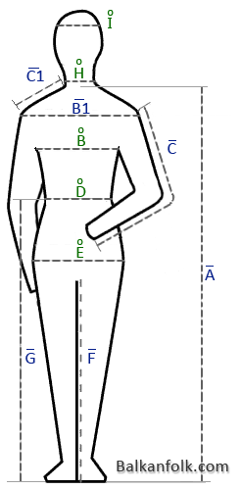
 |  |  | 1
– | A | Height (measure of length):
о | B | Chest (Girth):
– | B1 | Back - Shoulders (measure of length):
– | C | Arms (measure of length):
– | C1 | Shoulders (measure of length):
о | D | Shoulders (measure of length):
о | E | Haunch (Girth):
– | F
– | G | Outseam - Waist To Ankle (measure of length):
о | H | Neck (Girth):
о | I
о | Girth
– | measure of length

