INTERNATIONAL CHILDREN FOLKLORE FESTIVAL ''HANIOTI''
from 24 till 29 September 2009
Organized by:
Municipality PALLINI

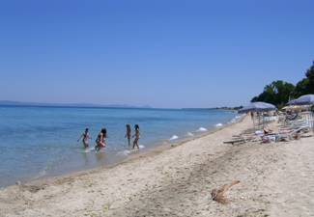
Hanioti is a small and very picturesque village in Halkidiki, situated on the peninsula's first prong, only a 60 minute drive from Greece's northern capital, Thessaloniki, visited by more then 200000 tourist every year. Upon arrival, every visitor will be captivated by this small picturesque paradise that has been designed to cater for the needs of even the most discerning traveler and guarantee a relaxing and memorable stay. The village features hotels with all the necessary facilities, numerous restaurants and traditional taverns that will satisfy every family, as well as modern bars and dance-clubs geared to providing evening entertainment to all age-groups. In the center of Hanioti you can see the Amphitheatre where the Festival is performed in presence of thousand visitors.
The accommodation is organized in apartments and hotels, the rooms are with 2-4 beds and only 5 minutes from the center and the beach.
Near the amphitheatre there are traditional restaurants where you will have breakfast and lunch.
During the Festival every Ensemble will have at least two appearances, one in Hanioti and one or two in Municipality Pallini. The concerts are in the evening accompanied with a defile. The diplomas and exchange of gifts will be after the concerts.
During the free days you can have rehearsal in the amphitheatre by making appointment with the organizers.
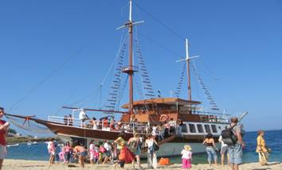
* Boat trip (10.00 - 17.00h) can be organized for everyone interested – boat party. You will take a boat tour to the second prong and visit the turtle island having breaks for swimming and sightseeing (price – 15€ per person).
* Last day can be organized two visits:
- Thessaloniki and Zejtinlik (Serbian military cemetery)
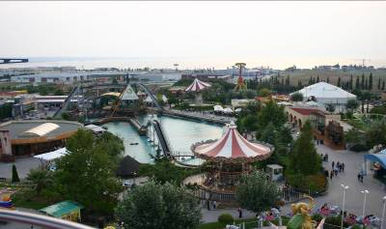
- Fun park – Magic Park, (17.00 - 20.00h, price: 6€ per person)

The traveling program for groups
1st day – arrival in the afternoon – free time
2 – 5 day – activities according to the program of the festival
6th day – departure
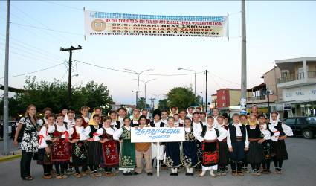
Terms for participation:
- On the festival can participate children from 5 to 16 years
- The Ensembles and singing groups must have at least 10 minutes show.
Participation fee (120€) can be paid in several payments and covers the accommodation (5 nights), breakfast, lunch and expenses for the organization of the festival (dinner is not included, gyro 2€). The first payment (30€ per person) should be done with the application and the rest should be paid till the arrival in Hanioti. On every 25th participant one person is free.
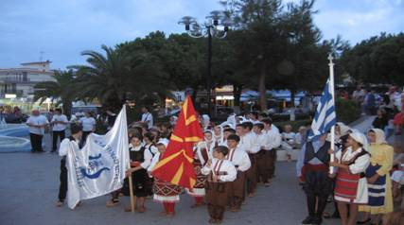
- The ensembles and groups must have their own transport (we can help with organization)
- In case the group is arriving by plane we can organize in your name a transport from the airport Thessaloniki – Hanioti – Thessaloniki on your expenses.

During the last 5 years on the festival „Hanioti“ has participated over 2700 children, from all countries from Balkan as well as groups from: Serbia, Greece, Macedonia, Montenegro, Hungary, Bulgaria, Ukraine, Georgia, Albania, Bosnia and Herzegovina etc.

The number of participants is limited.
The Organizer has the right to change the start of the festival (+/- 2 days) in accordance with the work of Municipality Pallini.

For additional information please contact us:
+ 389 75 285612 (speaking Russian)
+389 70 359747 (speaking English)
Web site: www.makfolk.com.mk
Email: biljanabojadzievska@makfolk.com.mk

