

２００８ IOV-JAPAN
KOKUSAI MINZUKO GEIJUTSU SAI
World Music and Dance Festival
Dear Folklore Friends,
"Hitococochi, Inc." is organizing the 2008 World Music and Dance Festival "Hakodate Kokusai Minzoku Geijutsu Sai" （HAKODATE World Music＆Dance Festival）in Hakodate city, Hokkaido, Japan. It will be held from August 19 to August 24, 2008.
The festival will combine four activities.
(1) An outdoor concert on a stage with a spectacular view in front of Hakodate Mountain.
(2) A parade in the historic Hakodate Bay area.
(3) Numerous smaller scale performances and workshops in cafes and music halls.
(4) Performances in local schools.
Hitococochi and IOV-JAPAN will welcome people ardently.
We would like to invite you to participate in this festival. We have summarized the details below, and would be happy to answer any further inquiries you might have. If required, we can supply Official invitations with your group name or other paperwork.
The people of Hakodate are looking forward to welcoming you to our town, to making your stay a memorable one, and to your performance.

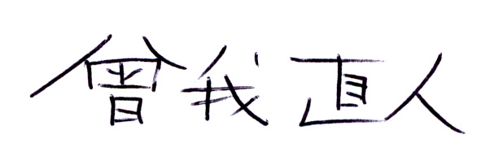
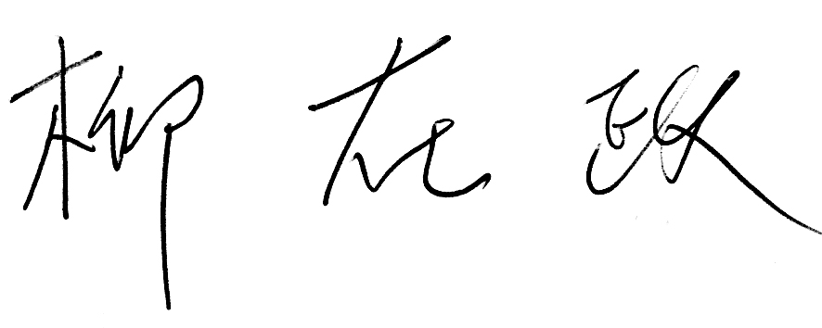
SOGA Naoto, Director IOV JAPAN President RYU JAEJUNG

INFORMATION
Name: 2008 World Music and Dance Festival "Hakodate Kokusai Minzoku Geijutsu Sai" Place: Hakodate Country: Japan
Date: Aug 19 - Aug 24, 2008 (The arrival date: Aug18, 2008 /The departure date: August26, 2008)
Edition: 1st Audience: about 30,000
Organization: Committee of World Music and Dance , UNESCO IOV JAPAN
Festival Director: SOGA Naoto Production: Hitococohi, Inc.
IOV-JAPAN: President RYU JAEJUNG
Requirements for participating groups: Operates according to IOV standards
- * play live music (not tapes, CDs, etc.)
- * perform with up to 25 people
  - * play for 5 to 30 minutes
  - We offer all participating groups:
- * Free meals and housing (hotels or host-families)
- * Transport in Hakodate (from/to New Chitose-airport/ Hakodate airport,)
- * General event insurance and First aid
  - * The possibility to sell goods, CDs, etc.
  - Obligations of each group:
- * Cover transport to/from New Chitose-airport/ Hakodate airport
  - * Ensure current medical insurance
  - Items we request participating groups to submit beforehand:
- * A DVD or DVD-R with performances (sorry, not DVD-RW)
- * A CD or CD-R for promotion
- * Some original photos
- * A description of the group
- * A list of festivals previously participated in
- ※Deadline :May 15

Here are the main rules regarding the participation of your group:
- Provide a deposit of 1 000 $USD JUN10th, 2008 to guarantee your participation. The deposit will be reimburse at the departure of the ensemble on AUG 26th.

An IOV-JAPAN account name
Beneficiary's name: IOV JAPAN Yoo JaeJung
Beneficiary's A/C No. ５０２２０５１
Addrss: 3-4-22,Oimazato Higashinari-ku Osaka,Japan
Postal code 537-0012
Beneficiary's bank name: The Bank of Tokyo-Mittsubishi UFJ,Ltd
SWIFT Address: BOTKJPJT
name of the Branch:TAMATSUKURI
Schedule：
Each appearance group, New Chitose-airport/ Hakodate airport arrival on Monday, August 18

August 19(Tuesday) rehearsal, a reception

August 20 (Wednesday)： School performance and a workshop,
Night：Festival performance（The outdoor stage）

August 21(Thursday)： School performance and a workshop,
Night：Festival performance（The outdoor stage）

August 22 (Friday)： School performance and a workshop,
Night：Festival performance（The outdoor stage）

August 23 (Saturday)： Performance and a workshop,
Night：festival performance（The outdoor stage）

August 24 (Sunday)： Performance and a workshop,
Night： festival performance（The indoor stage）

August 25 (Monda y) Morning： School performance

Leave each appearance group, Hakodate/ on, August 26(Tuesday)

Festival performance： From 10 to 40（It is approximately every day each group）
School performance： From 30 to 40（Each one or two groups）

Workshop（A primary schoolchild, a citizen object）： Around 60 minutes（Each group one or two days）

Contact: UNESCO IOV JAPAN
Postal code 537-0024
1-10-3,Higashiobase Higashinari-ku Osaka,Japan
Goichi Building 3F IOV JAPAN
TEL 81-6-6981-3952 FAX 81-6-6975-0323
E mail iov-japan@kmc-g.com

