Workshop for SERBIAN and MACEDONIAN dances

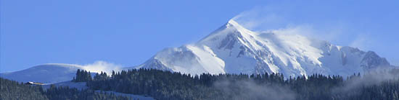

AT FLUMET
( French Alps near Mt Blanc)
from DECEMBER 26th to JANUARY 1st 2011

Arrival 26th afternoon, departure the 1st after lunch.

The 22nd seminar will be held in “HOTEL PANORAMIC” in FLUMET, 10mn from MEGEVE, nearest railway station: Albertville, nearest airport: GENEVE (after you have a bus to join Megeve). Skiing is possible in Flumet, Praz-sur Arly ,Megeve, or in “Col des SAISIES (place of the olympic games in 1992).

Chorégrapher, musicians :

Milan RADOVANOVIC
Dancer of the Serbian state folk ensemble “KOLO” and artistic director of the folk ensemble “OPLENAC” from Topola.
He’ll be accompanied by his accordionist Goran SANDIC and Marko KOJADINOVIC for kaval, flute and saxo.

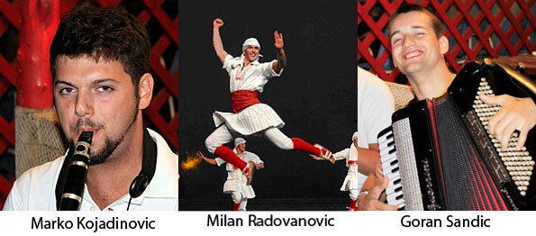

Programme :

Every morning, traditional dances of different regions of Serbia and Macedonia 3h, and 2h at the end of the afternoon. After dinner, parties with your favourite dances music and singing with Goran and Marko.
This programme may be changed considering the number of participants , or any reasons beyond our control.

Level of danse:
intermediate and advanced.

Organization :
Ivan et Françoise DJOKOVIC

Accomodation :
In Hotel Panoramic Flumet, each room with a bathroom.
For pictures and how to get there see the web-site of the hotel:
http://www.chalet-hotelpanoramic.com/

Price :
For 6 days in full-board ( from 26th dinner to the 1st after lunch) and seminar : 485 EUR (double rooms are reserved for couples, otherwise rooms for 3, 4 or 5).
The non-dancing accompanist will pay 370 EUR.
Extra charge for a single room 120 EUR.

Information registration :

Registration at the latest December 1st
Send to:

FRANCOISE DJOKOVIC
5 A Rue de l’Abbaye de Fontenay

21240 TALANT

FRANCE

Tél: 00 33 3 80 56 27 58 ou 00 33 6 60 43 52 64

e-mail francoise.djokovic@gmail.com

Your registration will be available after sending the filled in registration form and an advance payment of 100 EUR by bank transfer (ask for the number please)

All banks fees and commissions must be paid by the participant.
Have a look to our web-sites with photos and videos of previous seminars :
http://www.flickr.com/photos/francoise_djokovic/collections/72157625051377548/

In case of your cancellation after December 1^{tst} ,2010 no refunds will be possible.

Registration form

Surname………………………………………

First name…………………………………

Sex M F

Address …………………………………….

………………………………………………

Phone……………………………………….

E-mail

Accompanying adult……………………………

Your dance level:
- intermediate - advanced

