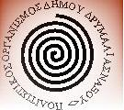

The association Νησιωτης / Nisiotis, partnering with :
The city of Naxos Drymalias
The cultural association of Naxos Drymalias
The cultural association of the villages within the county of Naxos Drymalias

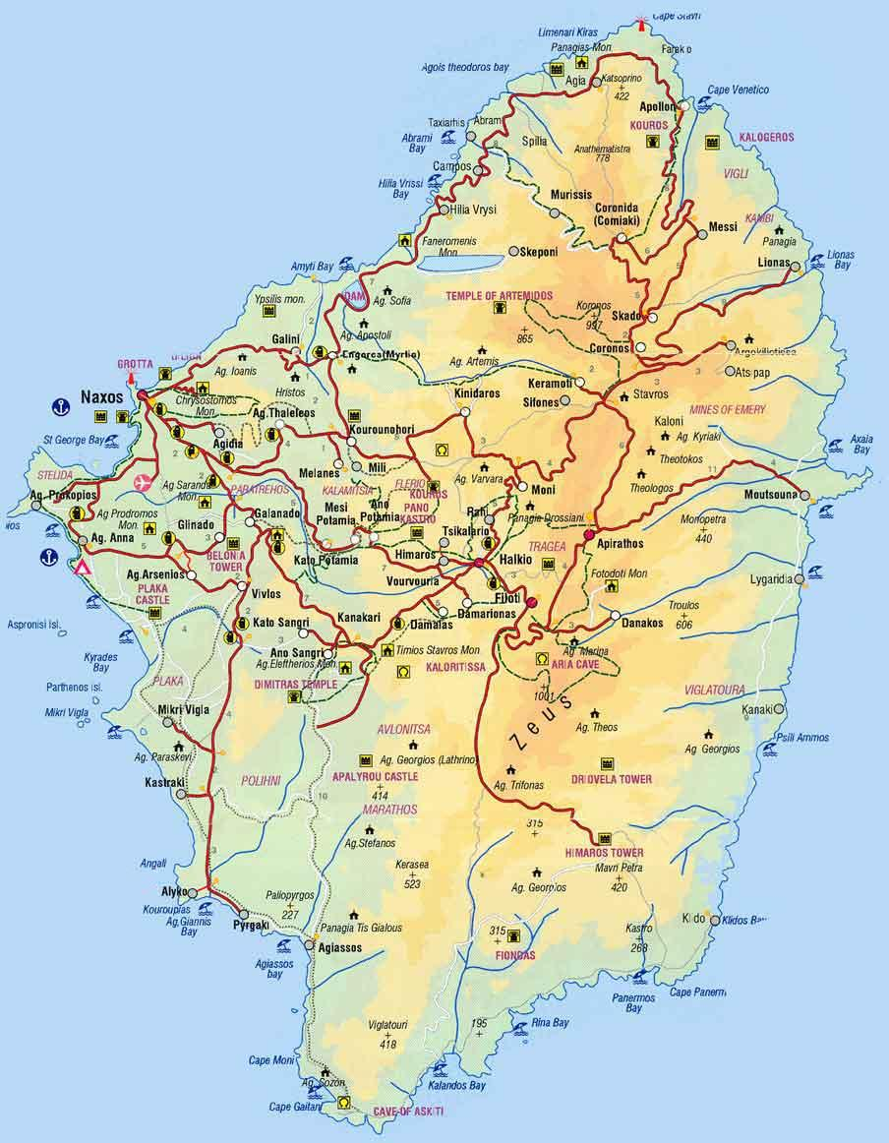

Suggest a unique 12-day seminar in Naxos, from July 19th to August 1st, 2010
Danse, Music, Songs, Culture, History & Tradition
in the heart of the tradition : Kyklades and Aegean Sea
A non-profit seminar

Registration form to be filled & sent by e-mail to :
nisosnaxos@gmail.com,
or through AirMail to : Nisiotis,23 rue Théophraste Renaudot, 75015 Paris, France

Last name : ……………………………………………………………………..
First name : ……………………………………………………………………..
Address : ……………………………………………………………………..
Zip code, city : ……………………………………………………………………..
e-mail : ……………………………………………………………………..
Phone : ……………………………………………………………………..
Mobile phone : ……………………………………………………………………..

Forecasted cost : 800 €
(hôtel - 12 nights -, breakfast, dinner, danse lessons (5 hours,each day),
teachers, musicians, concerts, evening parties, transportation within the island for the seminar)
All the money collected will be used to pay for the local expenses in Naxos only.
Contact / Information : nisosnaxos@gmail.com & (00) (33) (0) 6 03 78 28 77

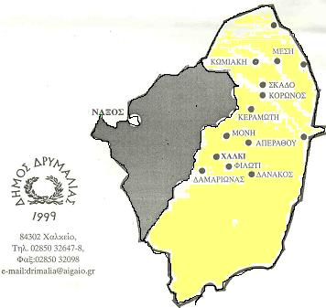

www.vησιωτης.gr www.nisiotis.gr www.nisiotis.fr www.nisiotis.info

www.nisiotis.org www.nisiotis.com www.nisiotis.net www.nisiotis.eu

to be informed on a regular basis about the seminar, the programm, the preparation, and the cultural life in Naxos, please send a mail request to : nisosnaxos@gmail.com

