First International festival-competition
«SUPER DANCE from folk to modern»
April, 26 – 29, 2013
St.Petersburg, Russia
Dear Friends,
The Centre of International Cooperation “Inter Aspect” and The Committee for Culture of St.Petersburg invite you to take part in the First International Festival-competition «SUPER DANCE from folk to modern». The Organisers are announcing that the Festival will take place from 26 to 29 of April 2013 in St. Petersburg.

The International Festival is being held as an event envisaged at promoting the choreographic art and a rendezvous of the talent and artistic perfection of dance groups from all over the world.
It is aimed at establishing artistic mutual relations and bringing together the groups from St Petersburg, regions of Russia and other countries with the view to present and enlarge the array of dance traditions, both time-tested and innovative.

THE FESTIVAL AIMS TO:
- Develop and strengthen cultural relations, cultural exchange, generate a creative climate favourable for the communication among participants in the Festival;
- Promote joint performances of ensembles from different countries and cities of Russia, in order to foster the respect for national traditions of other cultures and to stimulate the emergence of new masterpieces.
- Develop the professional skills of groups’ leaders;
- Search for and provide all-round support to new talents in the field of choreography (the best groups will be publicized on the web site and in the GOLD book of the Festival);
- Encourage music producers, organizers of concerts and festivals to develop further contacts with participant teams (invitation of the best groups to the concert tours and the international festivals);
- Carry out educational programs at schools intended to inculcate in youngsters a positive attitude towards ethnic diversity and to heighten their interest in traditions, customs and culture of various ethnic groups.
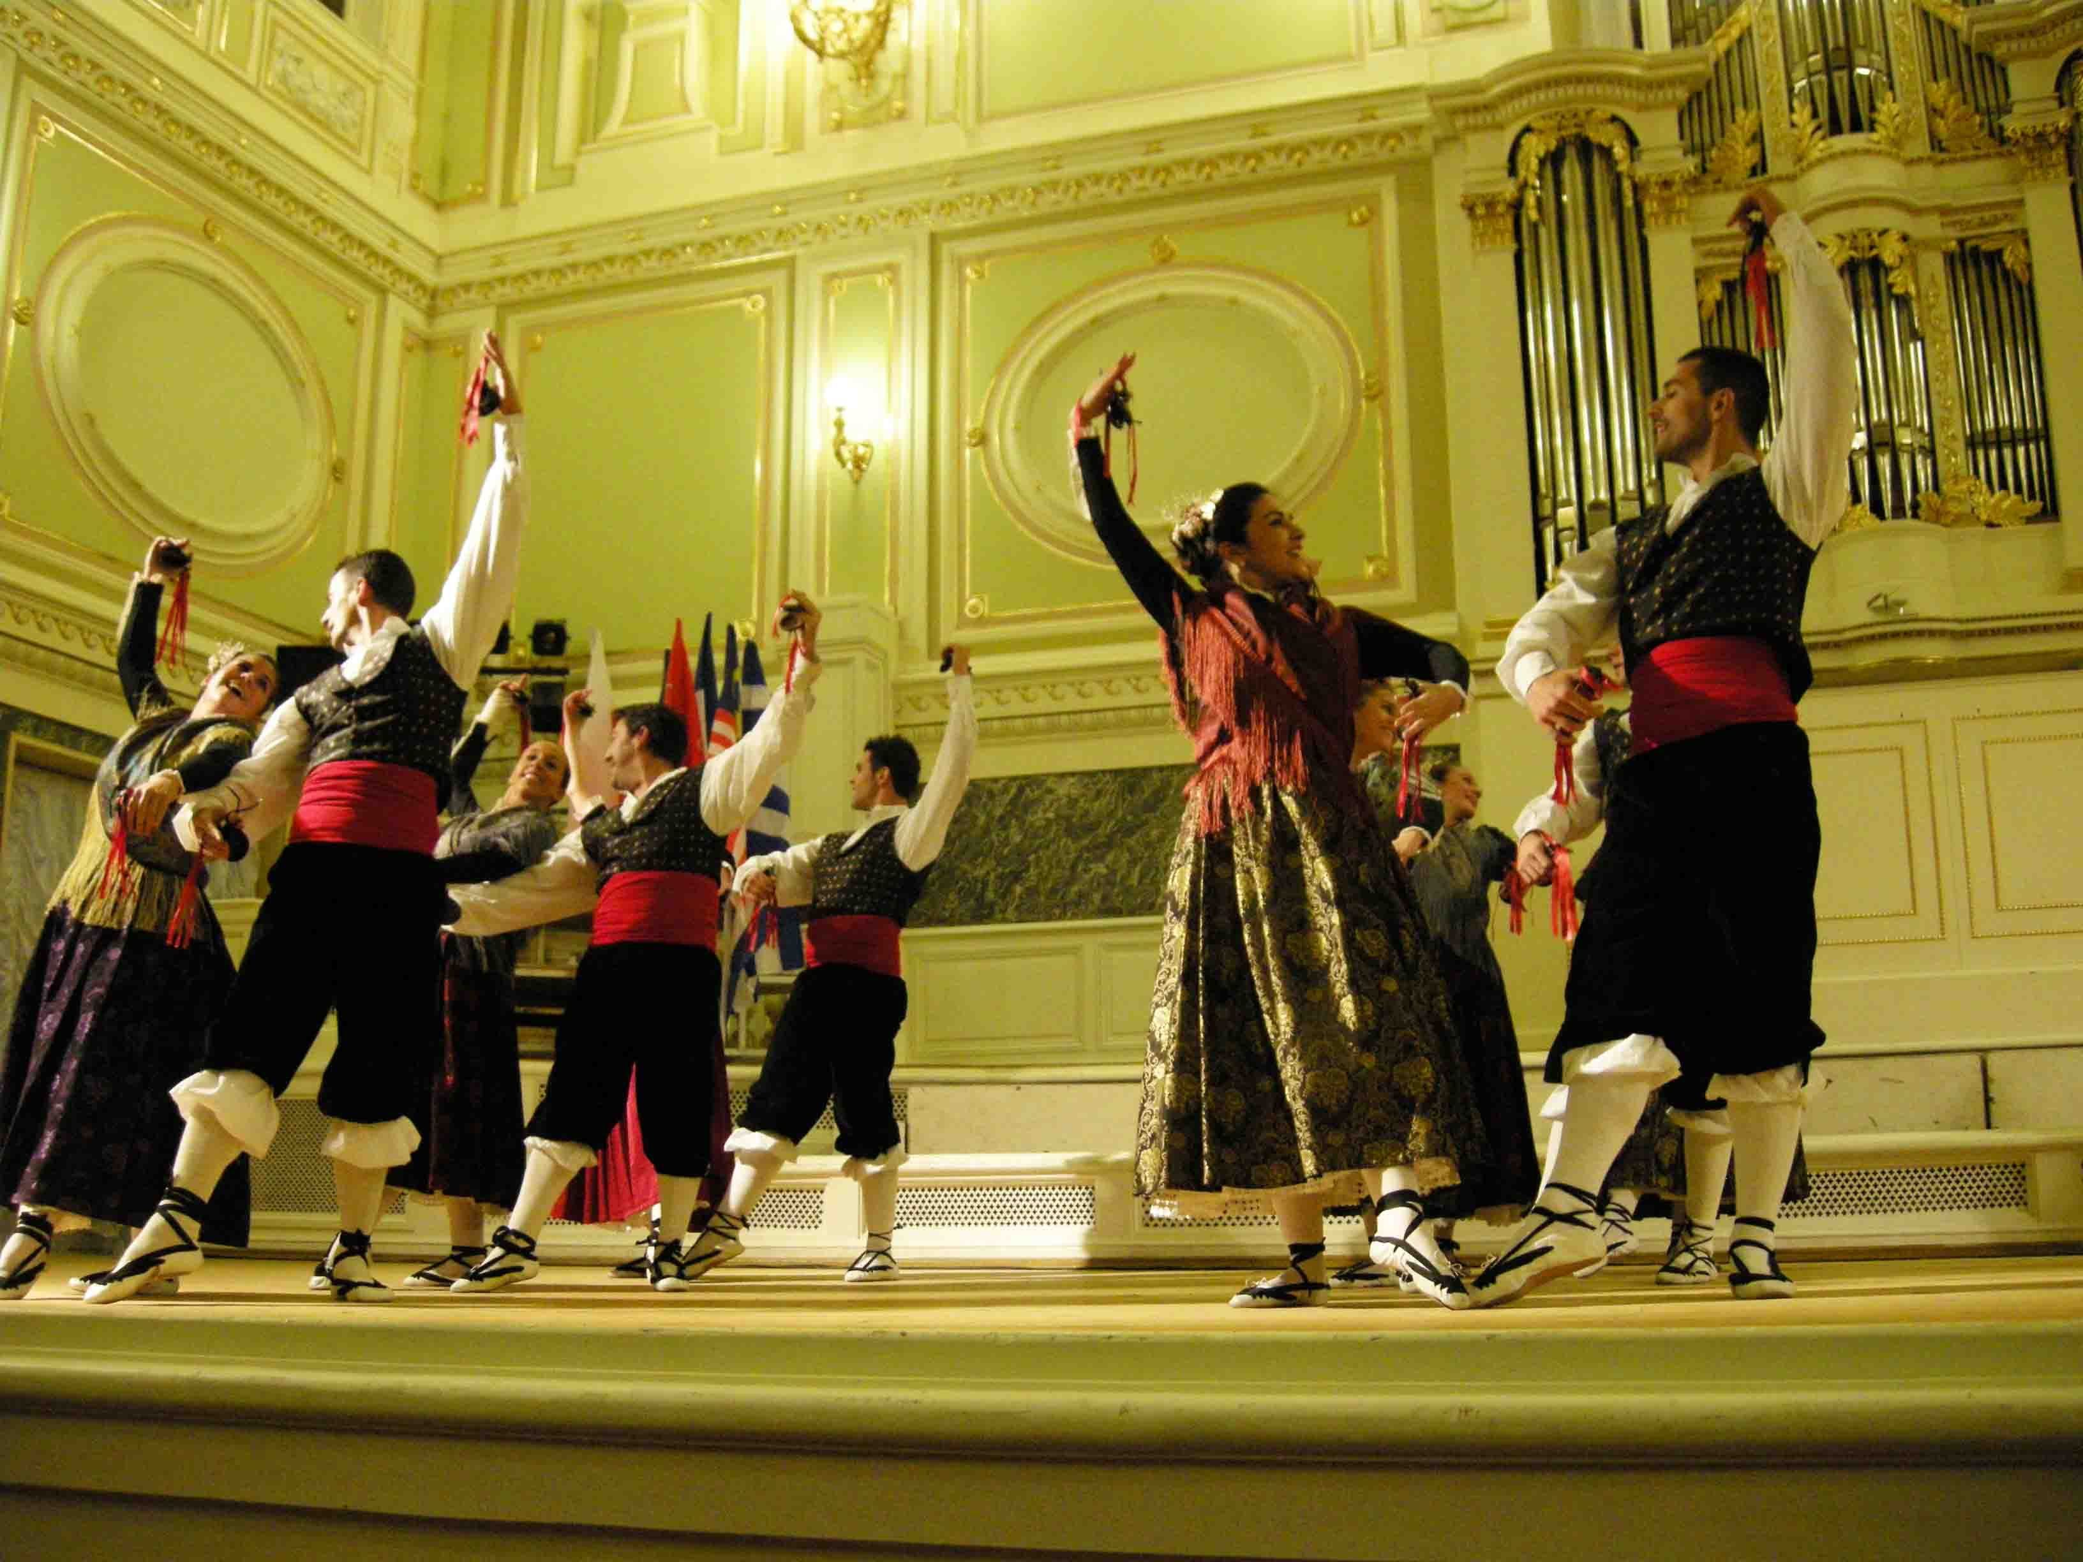

PARTNERS:
European Association of Folklore Festival (EAFF)
CID - International Dance Council
Department of Dance Council UNESCO in Russia
St.Petersburg State University of Culture and Arts
«Kaskad» Cultural Centre (Peterhof)
Creative Association «Art Attache»

PARTICIPANTS:
- The Festival is open to choreographic groups (with a minimum of 3 dancers) from around the world with varies choreographic styles;
- The age of participants is not restricted.
- The Festival open to professional and amateur groups

CONCERT VENUES:
- “Saint-Petersburg” Concert Hall (5/2 Pirogovskaya Embankment)
- «Kaskad» Cultural centre (2 Tsaritsinskaya street, Peterhof)
- State University of Culture and Arts (2 Dvortsovaya Embankment)
- Halls under St. Petersburg district Administrations
- Concert halls of educational institutions (secondary schools, higher education institutions)
- Cultural centres of St Petersburg and suburbs
THE FESTIVAL SCHEDULE:
April, 26 | Arrival of participants in St Petersburg. Registration of participants  Rehearsals on the concert stage  19.00 – Festival’s Opening Ceremony, gala concert of the participants
April, 27 | First round of International competition «SUPER DANCE from folk to modern» (performances of competitors)  Festival Concerts (concert halls of St.Petersburg and abroad)
April, 28 | Sightseeing tours of St Petersburg  Festival Concerts (concert halls of St.Petersburg and abroad)  20.00 – Friendship party (“Festival school”, presentation of festival diplomas and declaration of the groups to the second round)
April, 29 | Workshops, master classes, ateliers  Presentation “The Fair of the festivals” (for the leaders of the groups)  18.00 - Second round of International competition «SUPER DANCE from folk to modern».  Grand Prix contest, bestowal of awards, diplomas and souvenirs to Winners and Diploma holders. Festival’s Closing Ceremony
April, 30 | Meeting with members of the jury ( for team leaders)  Departure of participants

CONDITIONS:
- All participants of the Festival pay their travel expenses. The Organising Committee organize hotels (hostels) accommodation as well as to arrange for feeding and cultural program (excursions);

- Participant groups are to submit printed materials to be used in posters, booklets and catalogues of the Festival for information purposes; each team will receive free catalogues;

- Participation in Opening of the Festival with one piece up to 3 minutes and participation in concerts of the Festival, overall time of performance from 10 to 20 minutes (one concert minimum);

- All participants in the Festival are to submit their audio or video records to organizers (CDs may be mailed by post, and certain tracks may be sent by e-email):

- Each participant group will receive a certificate (diploma) and a souvenir of the Festival,

- Every group may participate in the fair on handicrafts at the Open and Close concerts (with their crafts products from native region).

- All the Festival events will be covered by press, radio and TV programs; participants’ information submitted to the Organising Committee will be used in Festival advertising materials;

- A delegation may include not only artists, but also accompanying persons. No limitations on number of artists and accompanying persons;

FESTIVAL FEE (for participants and accompanying persons):
«FESTIVAL PACKAGE 1 » 145 EUR per person (economic option at hostel)
- 4 nights in two, three and four beds rooms with bathrooms
- 4 breakfasts
- transfer “airport-hostel-airport” with guide
- sightseeing city tour by bus with guide (St. Petersburg)
- Opening ceremony with gala concert of participants
- public concerts with other groups
- the workshops
- transfers to the concert venues
- complete set of festival information materials

«FESTIVAL PACKAGE 2 » 205 EUR per person (3* hotel)
- 4 nights in standard twin/double rooms, bathrooms available
- 4 breakfasts on buffet
- 4 dinners on buffet at hotel
- transfer “airport-hotel-airport” with guide
- sightseeing city tour by bus with guide (St. Petersburg)
- Opening ceremony with gala concert of participants
- public concerts with other groups
- the workshops
- transfers to the concert venues
- complete set of festival information materials

Please notice! Hotel/hostel reservation is guarantee ONLY after 10% prepayment no later February, 15.

Accommodation, meals and culture program (excursions, bus, guides) for the participants is provided by «Art Attaché» Creative association
tel/fax: +7 (812) 328-39-21
website: www.artattache.spb.ru
e-mail: art-attache@mail.ru

CONDITIONS OF THE COMPETITION:
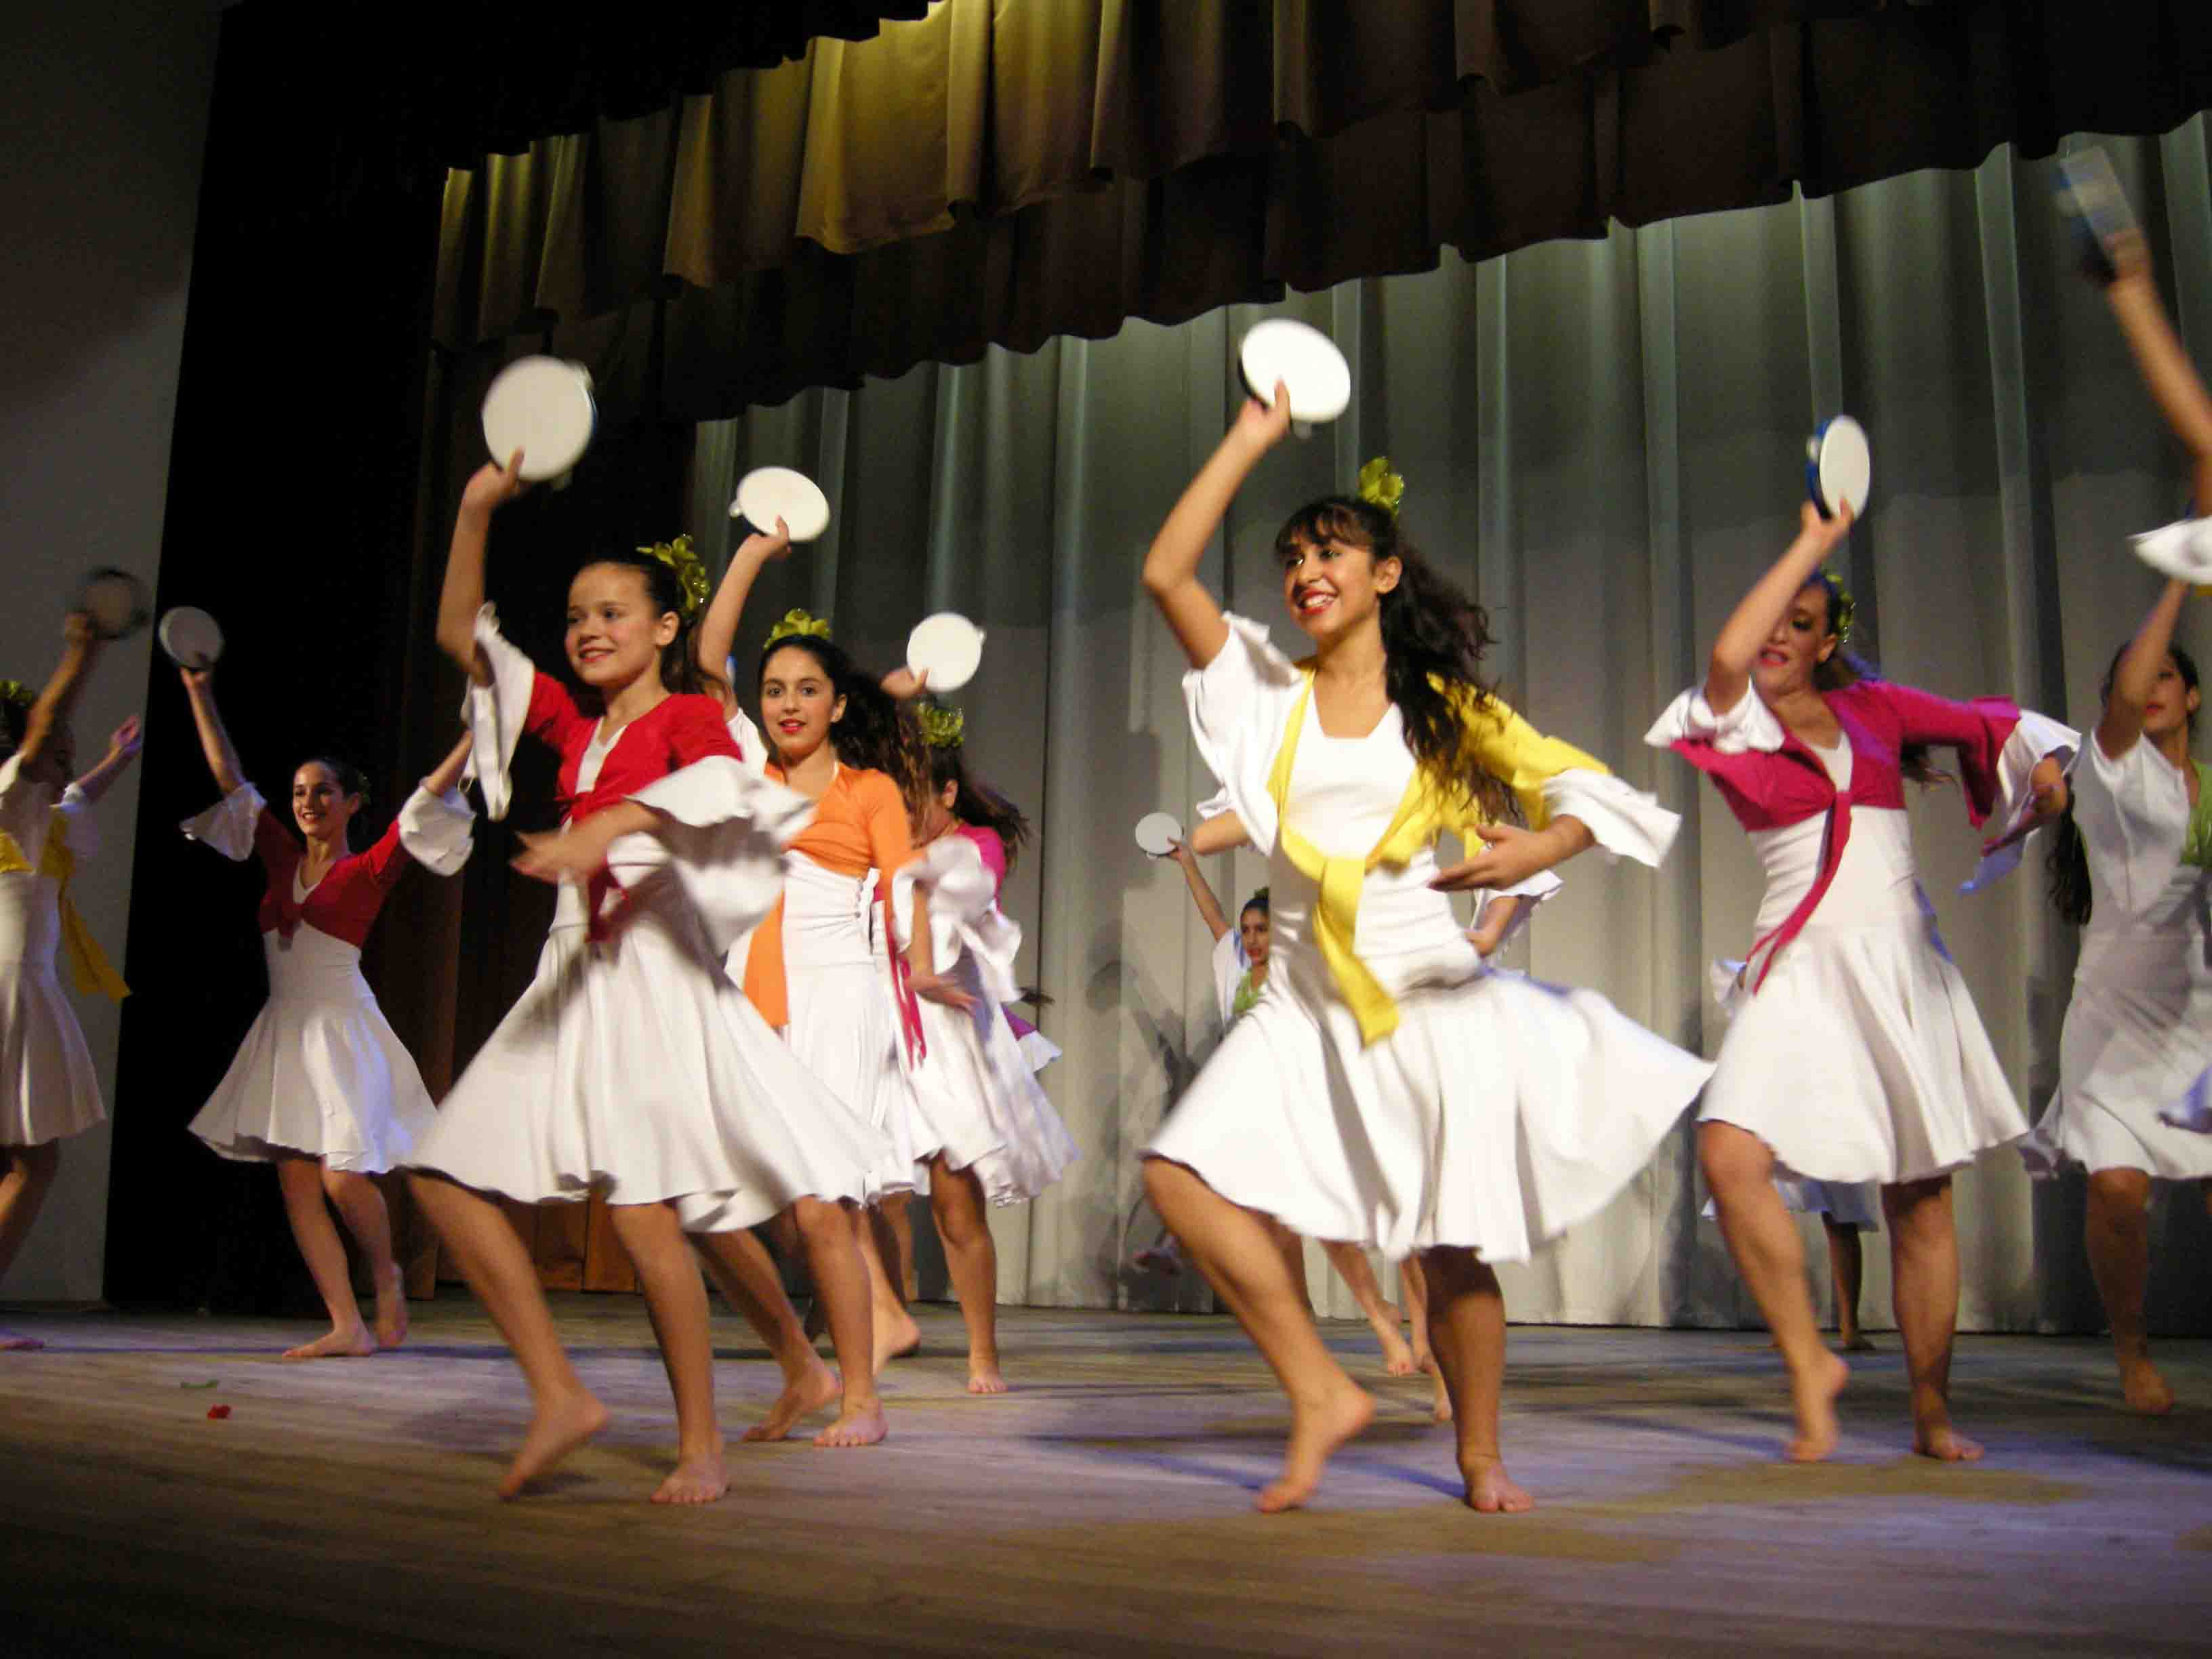
AGE CATEGORIES:
Group 1: Children – from 7 to 11 years;
Group 2: Juniors – from 12 to 18 years;
Group 3: Adults – from 19 years and above;
Every group can includes other age of participants but no more
than 30% from full group
CATEGORIES OF COMPETITION:

CATEGORY А: Classical dance and stylization
CATEGORY В: Folklore choreography (folk dance and stylization)
CATEGORY С: Modern chorography (jazz, modern, neoclassic, freestyle plastic)
CATEGORY D: Stage choreography (modern ballet, show groups, step)
CATEGORY E: Sport choreography (hip-hop, disco, techno, street, electric boogie, break dance)
CATEGORY F: Theatre of dances
CATEGORY G: Ball choreography (ensembles and show)
CATEGORY H: Oriental dances (ensembles and show)

CONTEST PROCEDURE:
The contest shall consist of 2 rounds:

First round

In the first round artists will present 2 (two) varies works up to 10 minutes.

Upon completion of the first round the jury will make decision as to winners and diploma holders of contest, and will award special prizes:

- Winner (Gold, Silver and Bronze diplomas by categories)
- Diploma of Participant
- Special prizes of the jury

Evaluation criteria:

- Artistry and performing skills of competitors;
- Representation of local material, both traditional and modern;
- Presentation of program (costumes, originality of direction)

Second round Grand Prix contest

Contest is open for general public.

Only Winners with Gold and Silver diplomas will pass in the second round (or other by decision of jury)
The group will perform one piece of 3 minutes duration.

By results of the second round the best group will be awarded:

Grand Prix | 30000 Rubles (~750 EUR)
Prix of leader’s council | 10000 Rubles (~250 EUR)
Prix of audience | 5000 Rubles (~130 EUR)

PARTICIPATION FEE IN COMPETITION:
To participate in contest, artists should submit an application and pay a fee:

Group from 3 to 6 members – 80 euro (per group)
Group from 7 to 12 members – 100 euro (per group)
Group from 13 members and more – 150 euro (per group)

The participants pay the fee immediately sending in the application form and no later than March 01, 2013. In case of refusal to participate in the event received after March 01, 2013 the entrance fee is not refund.

The Organizing Committee will send the bank details upon receiving the application form.

APPLYING FOR PARTICIPATION:
To participate in the festival and competition you should fill the application form and send it by e-mail:
super-dance10@mail.ru, no later than February 1, 2013.
The following materials are to be attached to the application form:
- Background (up to 20 lines in English);
- Colour photographs of group (in JPG (JPEG) format, up to 2 MB)
- video records (send certain tracks by e-mail by post: 199004 Russia, St Petersburg, 2 Linia, 17-28)
- Proposed repertoire.

ORGANISING COMMITTEE:
Tel./fax: +7-812-328-39-21
website: www.interfestplus.ru
e-mail: super-dance10@mail.ru

www.interfestplus.ru

