NEOS MARMARAS
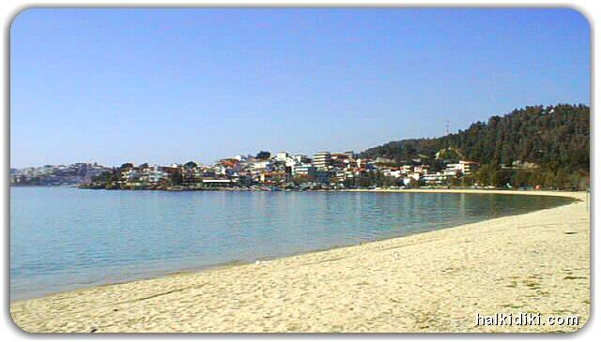
is the most cosmopolitan village in Sithonia. It combines sea and mountain, wild entertainment and romantic walks, Greek and international cuisine in a unique way. A walk along the pine-clad path that unwinds next the sea gives the visitor a unique amphitheatrical view of Neos Marmaras and the uninhabited island of Kelyfos (shell), just opposite, shaped like a tortoise.

The sun mirrors upon the sea, the sky changes a myriad of colors at sunset, the sand shimmers on the beaches, wet by the deep-blue waters and the scattered pebbles shine in elegance among the waves that reach the seashore. Only poetic and romantic images come to mind, as no one remains unmoved by nature’s magnificence, unfurled in front of visitors to Neos Marmaras every day.

- HISTORY
Neos Marmaras was founded in 1922 by refugees that came from the island of “Marmaras” in Asia Minor. Before then the area belonged to the Grigoriou Monastery of Mt. Athos. Today, to the east of the village, the monastery buildings, erected around 1905, survive, as well as the church of the Assumption of the Virgin, built in 1865.
During the 1960s, southeast of Neos Marmaras, “Porto Carras” was constructed, one of the largest hotel complexes in Greece. Its presence led to enormous development and turned the village into one of the main tourist destinations of Halkidiki. Because of the rapid development, the inhabitants of Parthenonas, an old village at the foot of Mt. Itamos, united with Neos Marmaras in 1970 and created the western section of todays village.

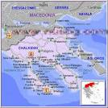
- HOW TO COME
Neos Marmaras is located on the Sithonia peninsula, 100 km from Thessaloniki's Airport. There are frequent bus services to and from Thessaloniki and the neighboring towns of Sithonia. Taxis can also be hired for airport transfers. Route, if you go by bus or car is
Thessaloniki - Nea Moudania - Nikiti - Neos Marmaras
- BEACHES
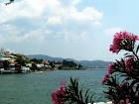
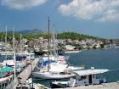
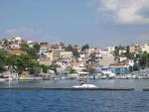
The beaches of Neos Marmaras are surprisingly diverse, endless sandy beaches or small coves, cosmopolitan or secluded, shallow or deep, depending on the visitor desires, but always with unspoiled, crystal-clear waters. Neos Marmaras’ main beach, with many fish-taverns and beach-bars, starts at the last cove of the town and stretches all the way to Porto Carras. Some of the most notable beaches for swimming are Lagomandra, Tripotamos, Paradisos, Azapiko, Spalathronisia, Ladario, Keramaria, Koutsoupia, Tristinika, Kohi and Korakas.

