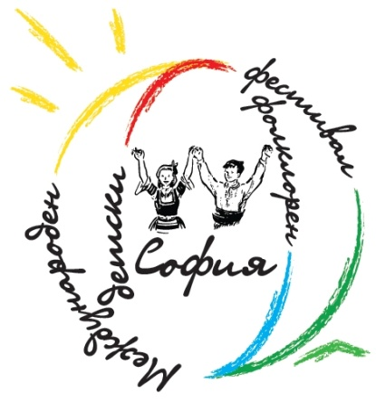
INTERNATIONAL CHILDREN’S FOLKLORE FESTIVAL
SOFIA 2012

BULGARIA, Sofia 1000
Geo Milev Str. 149 ent. 3, Apt. 28
tel: +359 888 210 823, +359 889 927 697
e-mail: festivalsofia@gmail.com, web: www.festivalsofia.com

REGULATION

The International Children's Folklore Festival Sofia 2012 will be organized in Sofia from 26 to 29 April, 2012.

The festival aims to present to the wide audience the children’s cultural heritage of different nations through the presentation of traditional folklore music in an authentic and stylized form.
The festival programme will include:
• concerts on open stages and indoor scenes in Sofia / depending on the weather and the region/;
• Folklore animation by children for children in kindergartens and schools;
• Costume road show;
• folklore art fair;
• recreation and sport

Terms of participation
1. The International Children's Folklore Festival Sofia 2012 is not a competition.
2. The participation in the festival is allowed to Children’s Ensembles and Groups that have to prepare choreographies or authentic folklore songs and dances. The group has to be accompanied by a live orchestra. Performances based on CD recording are not accepted.
3. The age limit of the participants is 8 to 14 years, with the exception of managers and musicians.

4. The group has to prepare 3 performances lasting respectively 25 minutes, 15 minutes and 4 minutes that will be presented on the concerts during the festival. The Ensembles should be ready to present their country, folklore costumes, traditions and customs to the Bulgarian children in English.
5. The group has to participate in all events during the festival.
6. The festival will be filmed by television and recorded on the radio, as participants are not allowed to have any claims for copyright of the photo, video and audio materials.
7. The groups will be allowed to sell their traditional souvenirs and other items which should be announced beforehand to the organizers

8. All groups participating in the festival will receive gifts and diplomas for participation.
9. Transportation costs to Bulgaria, Sofia and back, and during the festival are on behalf of the groups.
10. According to the rules of the International Children's Folklore Festival in Sofia, children will be accommodated in host families, as each family will host one child.
There is a possible option for hotel accommodation; in this case each participant has to pay a participation fee of 90 euros. Confirmation of hotel accommodation has to be submitted no later than 29 February.

11. The group should not exceed 25 people, including executives, musicians and drivers. For each person over the limit there is an additional fee of 90 euros for participation.
12.The groups have to arrive after 5pm on 26 April and depart until 12:00am on 29 April.
13. All participants of the festival must have valid health insurance covering hospital treatment.

Deadline for applications

The Groups have to submit their application forms by February 29, 2012 by sending a completed form to the organizers; history of the group and advertising materials; photos to be used in the Festival advertisement; DVD recorded performance that will be presented at the Festival.

The application form can be downloaded on www.festivalsofia.com

• The selected participants will be notified in writing by March 1, 2012

ORGANIZER
Association "International Children's Folklore Festival Sofia"
Organizing Committee of the Association:
Boris Filchev - President
MEMBERS
Milena Tsankova
Ivaylo Parvanov
CO- ORGANIZER
Children's Dance Ensemble "Zornitsa"

OFFICE OF ORGANIZATION;
BULGARIA, Sofia 1000
Geo Milev Str. 149 ent. 3, Apt. 28
tel: +359888210823, +359889927697
e-mail: festivalsofia@gmail.com
web: www.festivalsofia.com

