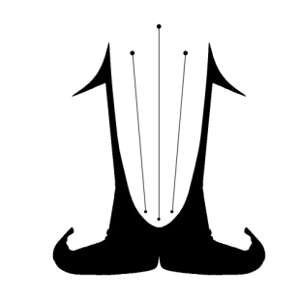
Festival organisation
LIRA FOLKLOR

Greece

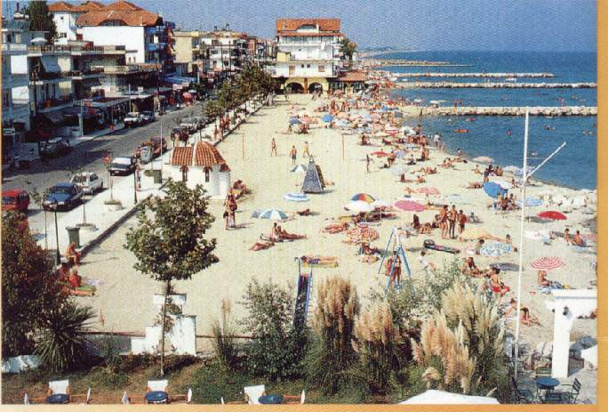
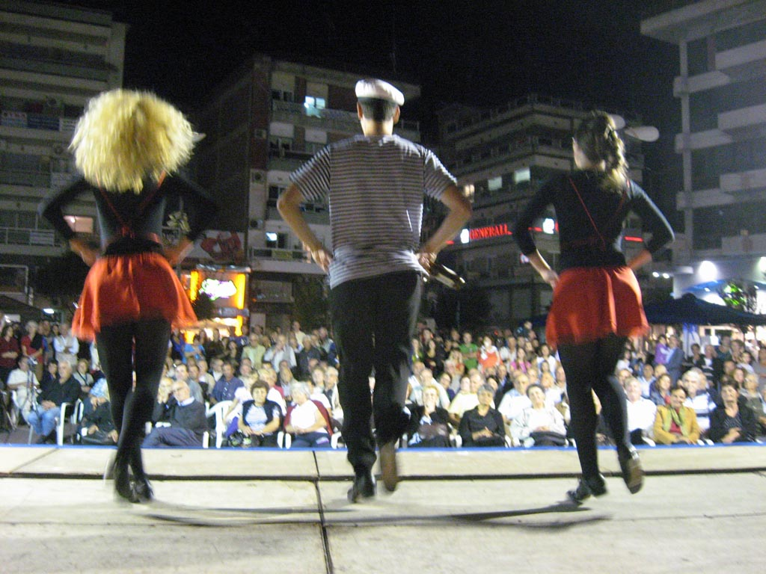
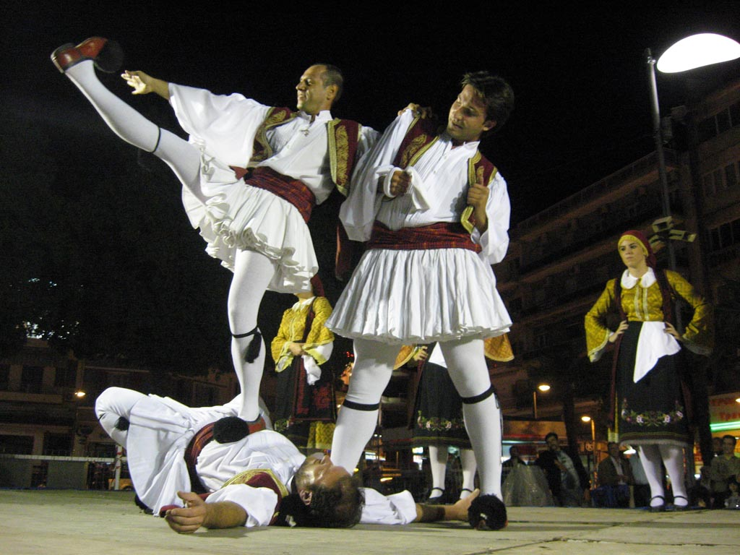
Ireland

We invite you to come on International festival of folklore in
“PIERIA’2015”
Paralia (Katarini) - GREECE
from 25th - 28th september 2015.

Participants are ensembles from Poland, Ukraine, Greece, Turkey, Serbia, Bosnia, Croatia, Czech, Slovakia, Bulgaria, Italy, Romania, Hungary…

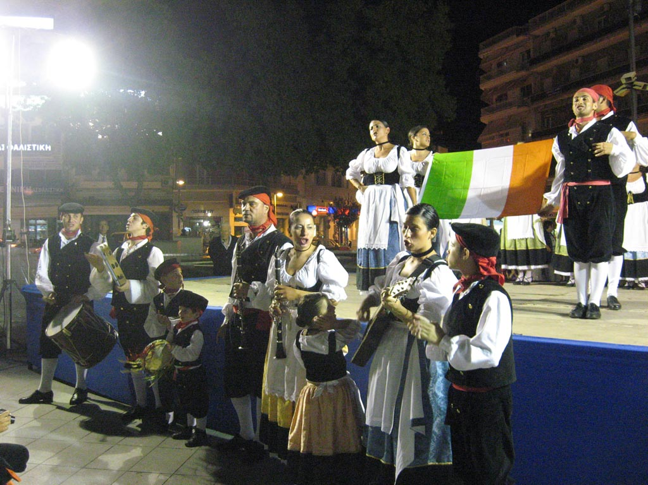
PROGRAM

1.day – Arival of ensembles. After 13h accommodation. Dinner,
overnight stay.
2. day – Breakfast, leisure. Dinner, parade,Festival opening,
performance in the center of the city. Receiving of certificates.
Overnight stay
3. day – After breakfast facultative tour – METEORI
with attendance of professional local guides. Dinner. Overnight stay.
4.day – Breakfast, abandonment apartmens (hotel) at 9h.

Price of registration fee is 75 € per person
Italy
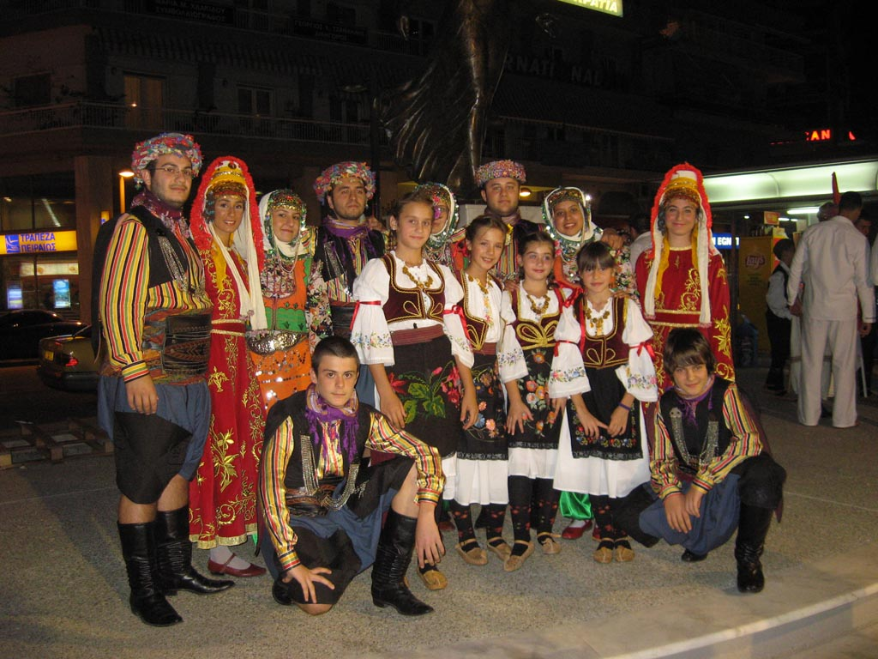
The arrangment price includes:

- Accommodation in Villas, triple rooms (no towels)
- 3 half board (breakfast and dinner) Serbia
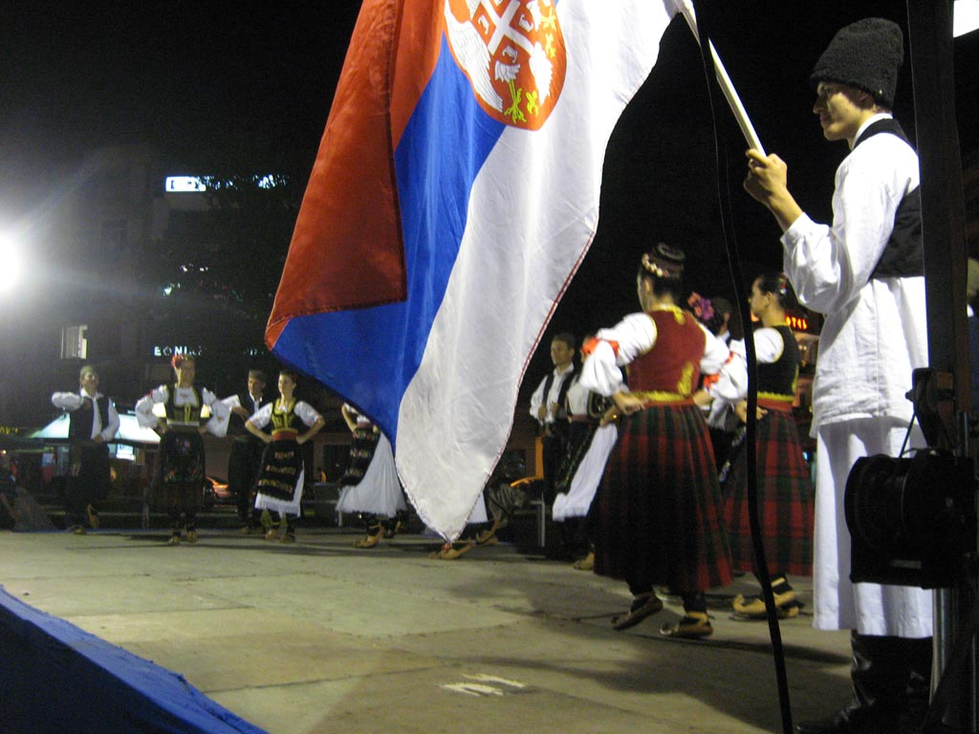
- Organization expenses
- Degrees
- On 25 participants 1 is free of charge

The arrangment price doesn't include:

- Facultative tours
- Health insurance
- Other expences Turkey

Additional day is 20 euro.

IMPORTANT: To be eligible for participation the Festival’s programme you have to pay reservation - 30 Euros per person and in case of cancelation there will be no refund.

ADDITIONAL INFORMATION: e-mail lirafolklor@gmail.com
Gordana Petrovic Zoric, Festival manager
https://www.youtube.com/watch?v=ET5Deba9BaI&feature=em-upload_owner
https://www.youtube.com/watch?v=zEHh6vq_pW0
https://www.facebook.com/LiraFolkFest?ref=hl

Note: All ensembles must provide their own music, leading orchestra or music CD. Each ensemble is obligated to set performance in duration of 10 minutes.

