1st International Folk Festival in Katerini, Pieria, Greece
(1st - 7th August 2012)

Organizers: Propantos Organization Center & Municipality of Katerini

The festival will be held in Katerini, Pieria (68 km from Thessaloniki), the land of the ancient Thracian tribe “Pieres” and the Muses, on the flanks of Mount Olympus, the mythological residence of the ancient Greek pantheon, and close to the coasts of the blue Aegean Sea. It will be held during the celebration of the 100th anniversary of the independece of the region. We expect that the festival will provide oportunities to the participants to learn about different cultures and people, create new friendships, exchange experience and contacts with other folk groups.

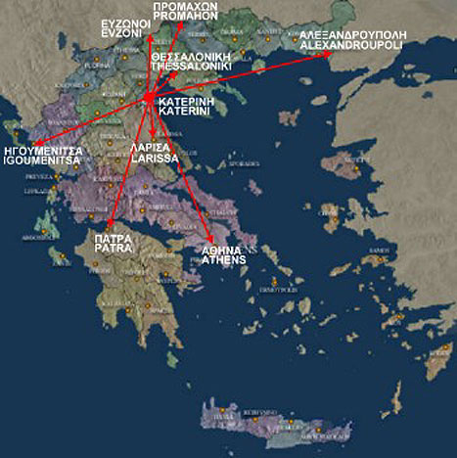 Google map location - Here

PARTICIPANTS
Type of groups that can participate: Traditional folk dance groups from Europe

PARTICIPATING CONDITIONS:
- Number and age of participants is not limited,
- The group should have prepared at least 10-15 minutes program accompanied by orchestra or CD,
- Each group should bring a flag of their country,
- Transport to and from the airport is on the group’s expenses. However, the organizing committee can provide transport to and from the airport on reasonable prices.

Registration fee:

The registration fee is 150 Euros per person which includes
- 7 days (6 nights) (half board - breakfast and dinner) in 2* hotels (in three-bed rooms) by the seaside of Pieria
- Only 3-4 performances for each group in the Festival
- After each performance meal will be offered to the participants
- Parade and presentation of the groups will be held at the central square
- Certificates of participation will be given
- Invitation letter will be provided if needed
- Every 25 participants one is free.

The participation fee DOES NOT include:
- If accommodation is exceeded, it will cost 25 Euros a day per person (half board - breakfast and dinner) in 2* hotels (in three-bed rooms)
- accommodation in double rooms, in case of availability, will cost an extra five euros a day per person
- Optional Tours (e.g. Mount Olympus, Archaeological sites of Dion and Vergina, traditional villages, coastal areas and beaches). Seasonal prices vary according to the number of participants.
- First aid and emergency support will be provided, but medical services must be covered by the group. The participant’s safety is on their personal responsibility.

* The final programme of the festival could be changed by the organizers if needed. Upon arrival, a detailed program of the festival and a person in charge will be provided to each group.

** The registration form should be sent before 31st of May, 2012 in order to confirm your participation. Once you have submitted your registration form, a confirmation will be delivered to you along with payment instructions. 30% of the total amount should be paid before 10th of June, 2012. The invitation letter will be sent to you after reveivimg your payment receipt. The rest of the total ammount for the group, must be received one week before your arrival in Pieria. In case of cancellation no refund will be given.

We are looking forward to meeting and cooperating with your group at our festival.

P.S. Do not hesitate to contact us if you need any further information.

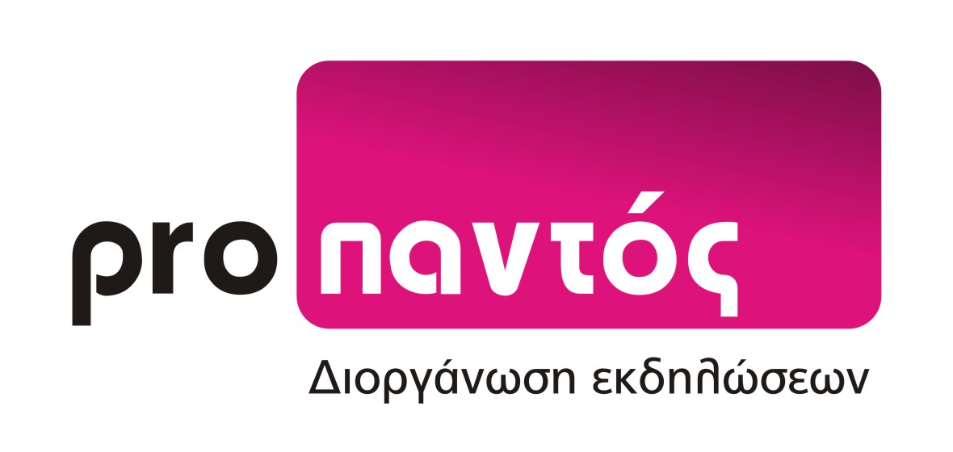

Propantos Organization Center
Mistra 2
60100 Katerini, Greece
Tel-fax: 00492351030787, mob 6973854977, 6977168392, e-mail: propantos@gmail.com

