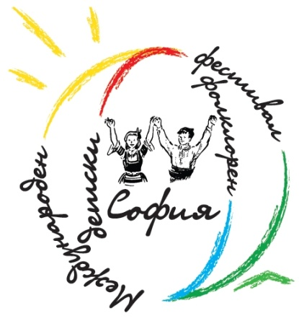
International Children's Folklore Festival Sofia 2012
BULGARIA, Sofia 1000
Geo Milev Str. 149 ent. 3, Apt. 28
tel: +359 888 210 823, +359 889 927 697
e-mail: festivalsofia@gmail.com, web: www.festivalsofia.com

APPLICATION FORM
1. Name of the ensemble ........................................................................................................................
We declare our willingness to take part in the International Children's Folklore Festival Sofia 2012, which will be organized from 26 to 29 April 2012 in Sofia.

................................................
Director of the ensemble
2. Country: ………………………………………………………………………………………………………………………………………….
3. Institution Represented: ………………………………..……………………………………………………………………………….
4. Name of Director ............................................... ................................................................................,
tel: ................................. . Fax: .................................. personal e-mail: ...................................................
5. Official address of the ensemble:
Street: ................................................ .....................................................................................................,
City: ..........................................., Post code: ..............................,
tel: .................. .........................., Fax: ........................... ............,
e-mail: .........................................................................................
6. Telephone number you will use during the journey from your country to Sofia: .................................. .................................................................................................
7. Total number of participants: .....................
Boys: ......................................,
Girls: ......................................,
musicians: .............................., accompanying: .................................., drivers: ...................................,
8. Language / s used by the ensemble: ...................................................................................................
9. Will there be an interpreter accompanying your group: ...................................................................
10. Type of transport you will use: .......................................... ...............................................................
11. Name of head of the orchestra: ……………………………………………………………………………………………………
12. Name of the Choreographer: …………………………………………………………………………………………………….…
13. Maximum duration of the programme: ............................................. ..............................................
14. Technical requirements for stage and sound system: ......................................................................
15. Other: ………………………………………………………………………………………………………………………………………….
…………………………………………………………………………………………………………………………………………………………….
…………………………………………………………………………………………………………………………………………………………….
Please send us the completed application form, advertising materials, photos, history of the ensemble, names of the dances included in the programme and a brief description of the dances, information about your participation in other festivals, participation in contests and awards won in recent years and DVD recorded performance no later than February 1, 2012.

