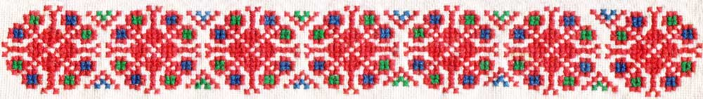

The GAIDA Ensemble from DIJON
Invites you to a Balkan dancing and singing
SEMINAR


with

Boris Dimitrov- Bulgaria

Sasko Anastasov- Macedonia

Vladimir Tanasijevic- Serbia Michelle Green- Singer

23rd-29th October 2010

At « la Maison Familiale »
Beaune-Grandchamp
Burgundy (France)

Translation of « CHOUETT’» = In French CHOUETTE means both : OWL (good-luck charm of our city of Dijon), and « SUPER ! »
Bulgarian dances

With Boris DIMITROV, former dancer of ZORNITSA from Sofia, co-director and co-founder of the Balkanfolk organization, he will be accompanied by the accordionist Danail TOTEV.

Macedonian dances

With Sasko ANASTASOV choreographer of VILA ZORA from the town of Veles, he will be accompanied by the clarinet player Stojan STOJANOV.

Serbian dances

With Vladimir TANASIJEVIC artistic director of the Belgrade ensemble BRANKO KRSMANOVIC, he will be accompanied by the accordionist Aleksandar SMREKIC.

Balkan songs

With Michelle GREEN : Co-founder and artistic director, since1986, of the Paris DJANAM choir whose purpose is both promoting the specific rhythms and styles of the Balkans, and sharing the warm atmosphere of their traditional celebrations. Michelle Green has worked with singers and musicians from different countries to increase her knowledge and practice as a singer and instrumentalist.

Information about the seminar

Reception :

It opens on Saturday the 23rd of October at 2.00 PM, there will be a presentation of the programme at 6.00 PM followed by a welcome drink.
The seminar ends on the 29th of October after lunch.

Dance classes :
From the 24th of October in the morning to the 28th of October in the evening (except on the afternoon of the excursion)
6 hours of dancing a day :
-2 morning classes from 8.30 to 12.00
(half an hour for tea or coffee-break)
--2 afternoon classes from 3.15 to 6.45
(half an hour for tea or coffee-break)

Singing classes :
- from 11.00 to 12.00
- from 3.15 to 6.45 (half an hour for tea or coffee-break)

Accommodation :
At the « Maison Familiale Beaune-Grandchamp ». En-suite rooms for 2 or 3 people.Towels not provided.

Excursion :
We plan an afternoon to discover this part of Burgundy, especially the splendid « Hospices de Beaune ».

Evenings :
Every evening, our teachers and their musicians will offer us the possibility to dance and sing together, and we also plan some theme-parties.

Fees :
Classes, full board and excursion : 450 euros
Gaida membership fee : 10 euros
Accompanying people : 300 euros (full-board + excursion)
Classes only : 220 euros

It’s possible to come for 1,2,3…days (inquire about the fee) .

Vegetarian meals should be mentioned on the application form.

REGISTRATION

Dead line for registration :
10th September 2010

Your registration will be valid when we receive your
filled in registration form at gaida.danse@gmail.com and a deposit of 150 Euros per person by bank transfer to :
Association Folklorique GAIDA

IBAN : FR 67 20041 01004 0515059K025 04

BIC : PSSTFRPPDIJ

All bank fees are to be paid by the participant.
The rest of the registration fee is to be paid in cash (Euros) on your arrival.

Dance and singing classes : you can choose from the following options

Option 1 : All dance-classes for beginners
Option 2 : All dance-classes for advanced
Option 3 : Bulgaria beginners and advanced +
Macedonia beginners
Option 4 : Bulgaria beginners and advanced +
Serbia advanced
Option 5 : Macedonia beginners and advanced +
Serbia beginners
Option 6 : Macedonia beginners and advanced +
Bulgaria advanced
Option 7 : Serbia beginners and advanced + Bulgaria beginners
Option 8 : Serbia beginners and advanced +
Macedonia advanced
Option 9 : All the singing classes
Option 10 : All the singing classes + one beginner dance-class from 8.30 to 10.00
Option 11 : All the singing classes + one advanced dance-class from 8.30 to 10.00

Organization and contact

Association Folklorique GAIDA

Mail : gaida.danse@gmail.com

More information: call the Gaida phone number :
Paulette : 00.33.3.80.41.29.47

The « Maison Familiale Beaune-Grandchamp » is situated at 8 km from Beaune in the countryside. It is an excellent starting point for walking and cycling. Horse-riding possible nearby.

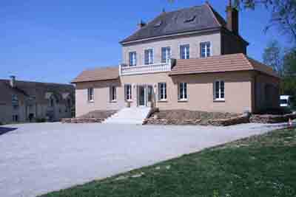

Transport :

- By train: arrival at Beaune station (direct TGV from Paris, or changing at Dijon) We will pick you up at the station.
- By plane : to Paris and then by TGV. Or Lyon St Exupéry airport, and by train from Lyon to Beaune.
- By car : A6 motorway, Beaune-centre exit. Road map to be sent later.
- Address :
Maison Familiale de Beaune-Grandchamp
5 rue de la Corvée de Mailly
21200 Ruffey-les-Beaune
France


23rd - 29th October 2010

Registration form

Surname………………………………………..........

First name………………………………...............…

Address …………………………………..................

………………………………………………................

Phone number……………………….......................

E-mail......................................................................

Accompanying adult……………………….....……

Your choice of option:

Vegetarian meals : yes no

I have sent a deposit of 150 Euros by bank-transfer to :

Association Folklorique GAIDA

IBAN : FR 67 20041 01004 0515059K025 04

BIC : PSSTFRPPDIJ

